CS404 QUIZ 1

NAME:

1. True or False (5 points each). Related outcomes: 6

  - 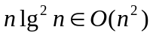 [ ]

  - 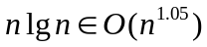 [ ]

  - 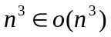 [ ]

  - 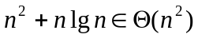 [ ]

  - 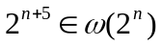 [ ]

  - 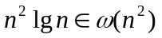 [ ]
2. Prove that 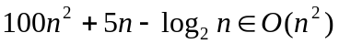using Related outcomes: 2

- (10 points) the definition of O.
- (10 points) the limit rule.

3. Analyze the following divide-and-conquer algorithm. Related outcomes: 5, 8

DC(int n)
{
if (n <= 4)
return; // running time is 1
for (i=0; i< 4; i++)
DC(n/2);
for (i = 1; i <= n; i++)
constant work;
}

a. Write the recurrence for the running time of the algorithm, T(n). You can use c to represent constant work (10 points).

b. Suppose n is a power of 4. Solve for T(n) using recursion tree method (10 points).

